Why Markmentum Research?
Traditional buy-and-hold frameworks often lack the context needed to actively manage risk across modern market regimes. While it can still play a role, today’s markets are more volatile, more cyclical, and more sensitive to macro forces than in the past. As a result, investors increasingly need tools that help manage risk dynamically while seeking consistent compounding over multiple time horizons.
Markmentum Research provides a volatility-adjusted, probability-driven investment research framework designed to help investors better understand risk and reward across daily, weekly, and longer-term timeframes. By combining price behavior, trend structure, and quantitative signals, our approach helps users tilt exposure toward asymmetric opportunities where upside potential outweighs downside risk—while avoiding crowded, stretched setups.
Markmentum emphasizes disciplined, data-driven decision-making to support capital preservation and repeatable outcomes across changing market regimes.
Probable Ranges
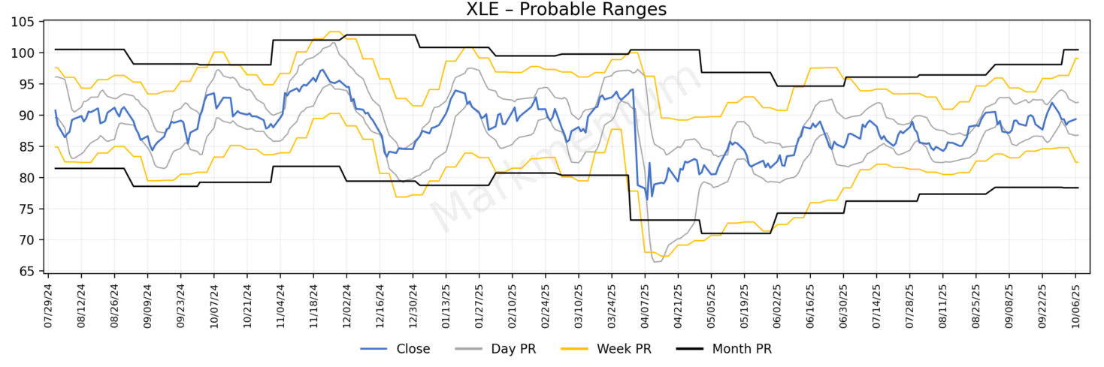
We forecast daily, weekly, and monthly probable ranges. These ranges frame risk: near the bottom = limited downside / more upside; near the top = limited upside / more downside. To determine these ranges, we look to what the market is signaling in terms of price action, volatility, and volume.
Price action – There is an opening price, high price, low price, and closing price. We calculate the volatility of the high and low prices independently. Based on this volatility over a time series we can make statistical predictions for the high and low for the next period.
Volatility – Volatility can have its own volatility or “vol of vol”. Looking at the vol of vol for the high and low assists with the predictive model.
Volume – Think of volume as the votes in an election. When the turnout in a particular election is high, the elected official is said to have won a mandate from the populace. When the turnout is low, no such mandate exists. It’s the same with volume. We can analyze the volatility of volume over time to assist with the predictive model.
Looking at price, vol of vol, and volume together is significantly better at determining the weather of a market than just looking at the current price compared to an arbitrary moving average. We can see and interpret signals from the market just like a weatherman uses signals from a doppler radar system to interpret and determine rain or sunshine.
Important to note is that price can move outside probable ranges at certain times. If all prices were included, the ranges would lose their usefulness. A probable range break can be a market signal in and of itself. Markets are forward looking, and material changes can happen quickly.
**Range breaks themselves can be meaningful signals — often marking shifts in market conditions.**
How to use:
- When price nears the top of the probable range, upside is limited; the trade is to manage downside risk.
- When price nears the bottom of the probable range, downside risk is limited; there is an asymmetrical risk vs reward setup.
Trend Lines
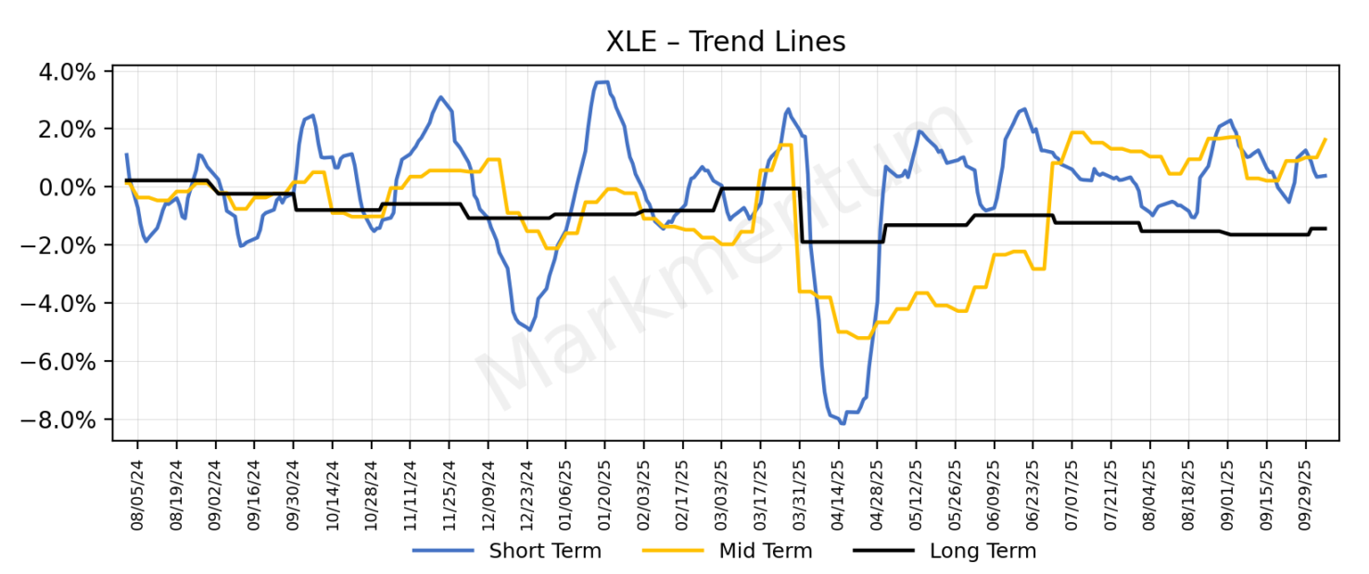
Price volatility for the high and low, vol of vol for the high and low, and volume volatility gives us 5 critical pieces of information to determine a trend factor for both the high and the low. Netting the trend factors tells us even more. If the net trend is negative, then the trend is lower and vice versa. Now do this same process for daily, weekly, and monthly and you have trend lines over different time scales.
The trend lines tend to follow a divergence/convergence pattern. The opportunity to make asymmetrical trades is to understand the pattern and time your trades accordingly while being mindful of the probable ranges on daily, weekly, and monthly timeframes.
The most powerful signal: when short-term diverges from long-term. The opportunity is to anticipate convergence.
How to use:
- When short-term and long-term trends diverge, look for convergence trades.
- When short-term and long-term trends converge, prepare for the next divergence setup.

Probable Anchors
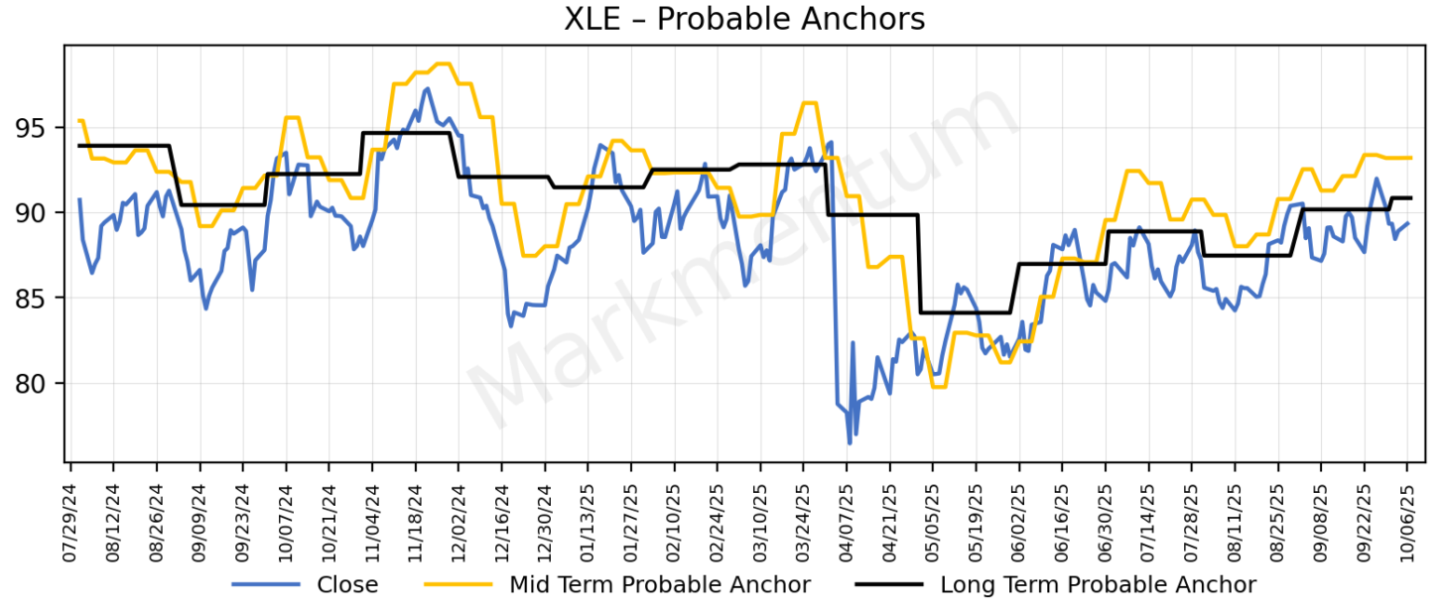
We know that the trend lines diverge and converge on a cyclical basis. We can extrapolate, using these trend lines converging, what an expected price anchor may be. Markets are dynamic — new data will shift these anchors. Also, a bit of smoothing is employed for these anchors. These are not meant to be precise anchors. They are a risk management tool. When price is close to an anchor, upside asymmetry is reduced; when further away, risk/reward is more favorable.
How to use:
- Close tends to move away and towards the probable anchors on a regular basis.
- There is an asymmetrical risk vs reward setup when there is distance between the close and the probable anchors.

Gap to Long-Term Probable Anchor
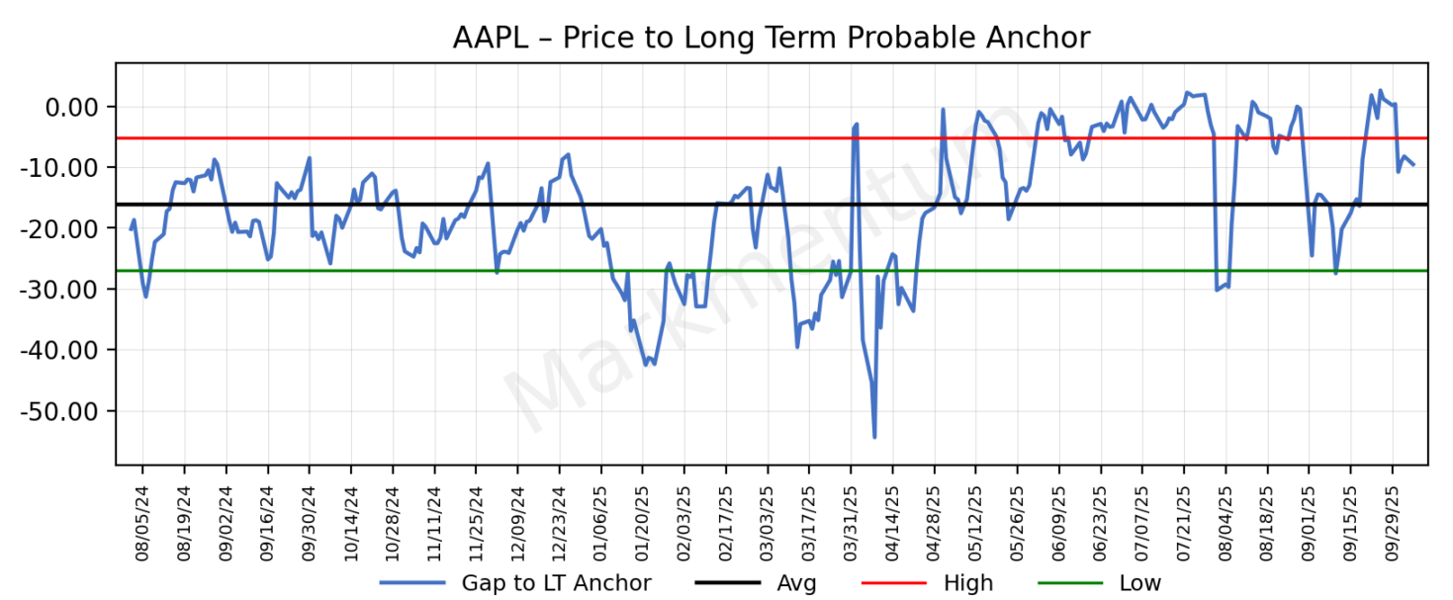
This graph plots the close to the long term probable anchor over time, with markers for the average gap and one standard deviation above and below the average. Above the red line = risk > reward. Below the green line = reward > risk.
How to use:
- Below the green line → asymmetrical reward opportunity.

- Above the red line → mean reversion risk.
30-Day Rvol Z-Score
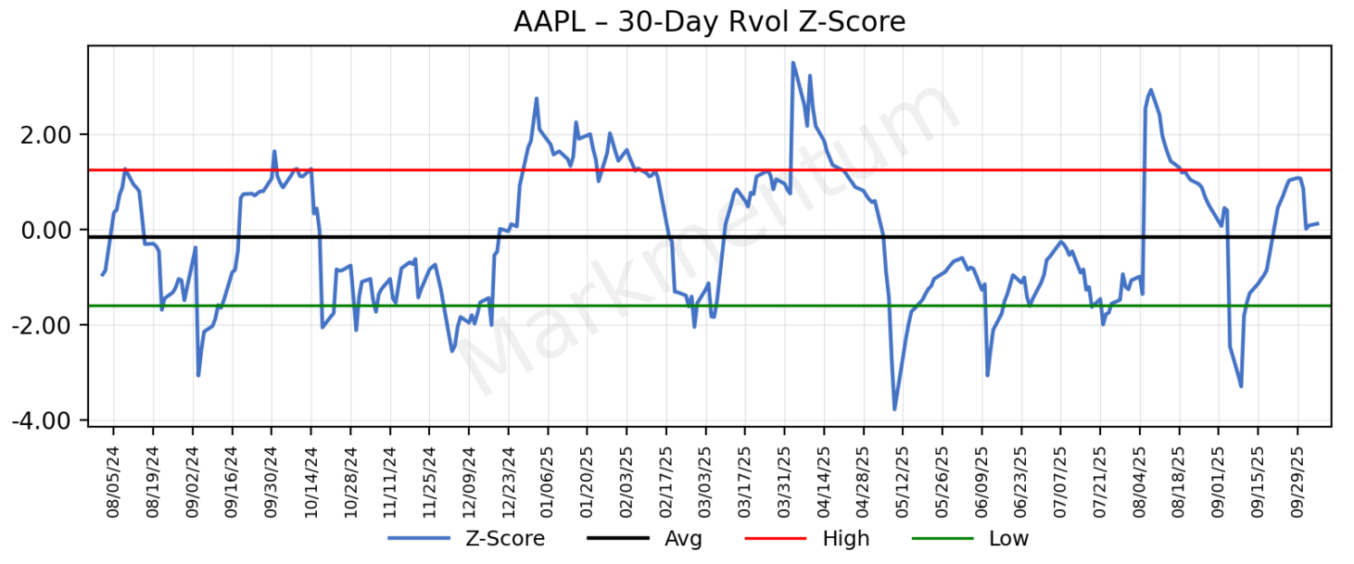
Z-Score of 30-day realized volatility. A Z-Score is a numerical measurement that describes a value's relationship to the mean of a group of values. At the extremes, the potential for a change in direction increases.
How to use:
- Above the red line → realized volatility is stretched high; potential for mean reversion or cooling off increases.
- Below the green line → realized volatility is unusually low; potential for a pickup in volatility ahead increases.

Z-Score Percentile Rank
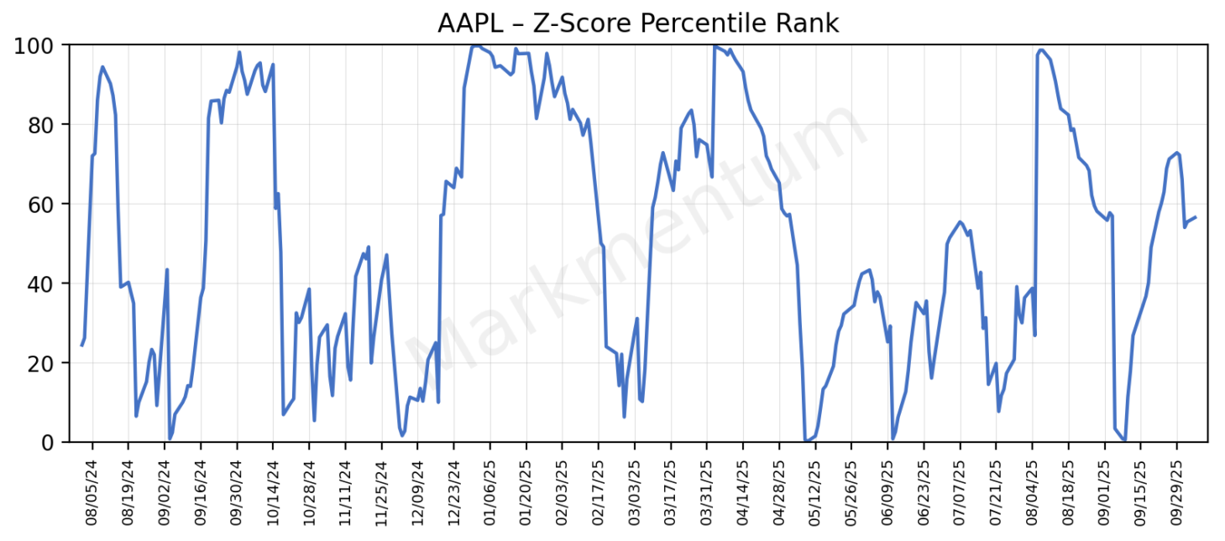
Trailing one year Z-Score percentile rank.
How to use:
- High percentile rank (80–100) → volatility is crowded/extended; odds of reversal increase.
- Low percentile rank (0–20) → volatility is compressed; odds of expansion increase.

Realized 30-Day Annualized Volatility
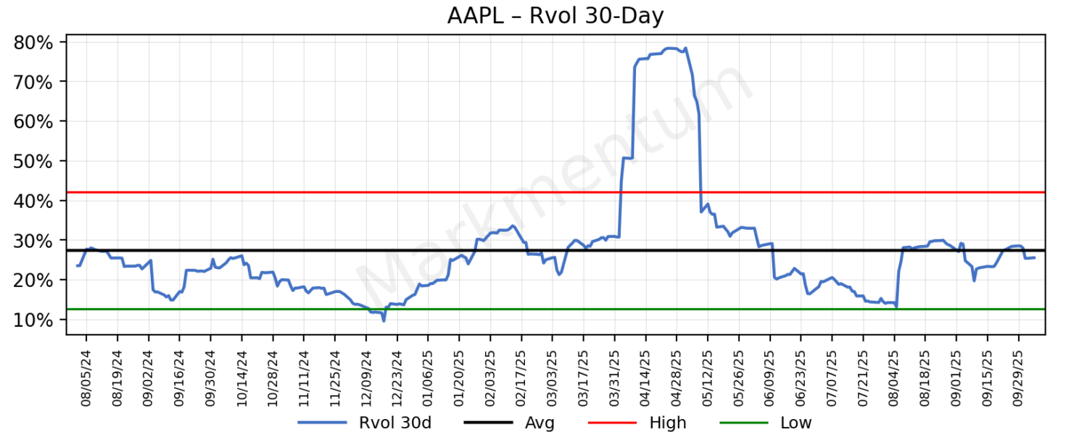
When it is elevated or suppressed, potential for a change in course increases.
How to use:
- Above the red line → volatility is stretched; risk of reversal or cooling off increases.
- Below the green line → volatility is unusually suppressed; odds of expansion rise.

30-Day Sharpe Ratio
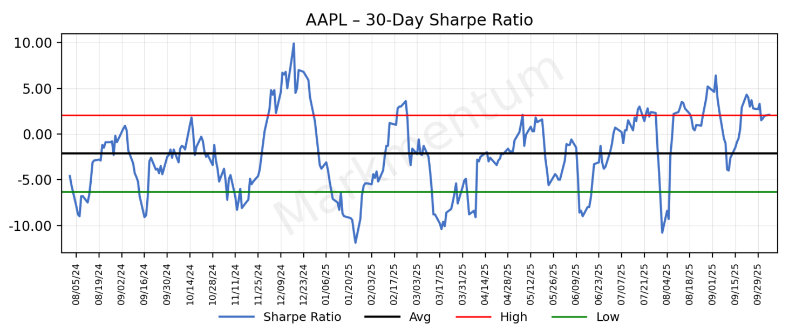
The Sharpe Ratio measures the performance of an investment compared to a risk-free asset. When it is elevated or suppressed, potential for a change in course increases.
How to use:
- Above the red line → Sharpe is stretched high; risk/reward may be deteriorating (watch for mean reversion).
- Below the green line → Sharpe is stretched low; potential for rebound or recovery increases.

Sharpe Ratio Percentile Rank
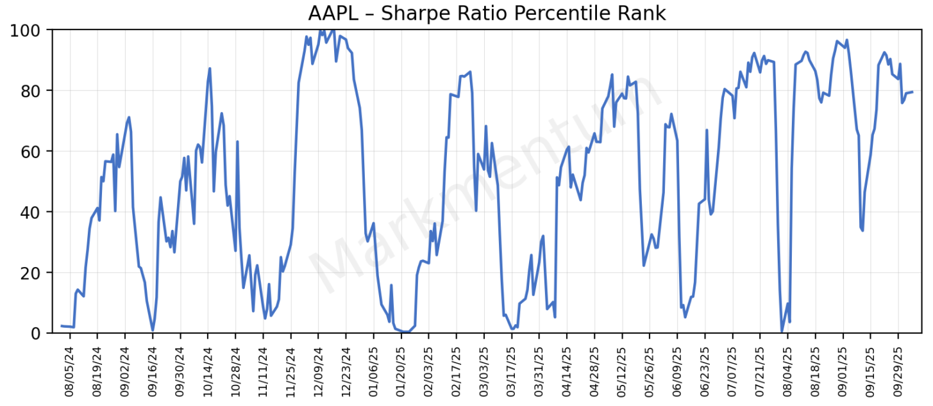
Trailing one year Sharpe Ratio percentile rank. As market participants rotate in and out of instruments, this can often appear as a sine wave.
How to use:
- High percentile rank (80–100) → Sharpe is stretched; risk of mean reversion grows, upside reward is limited.
- Low percentile rank (0–20) → Sharpe is depressed; potential for rebound or improving setups increases.

Implied Volatility Premium/Discount
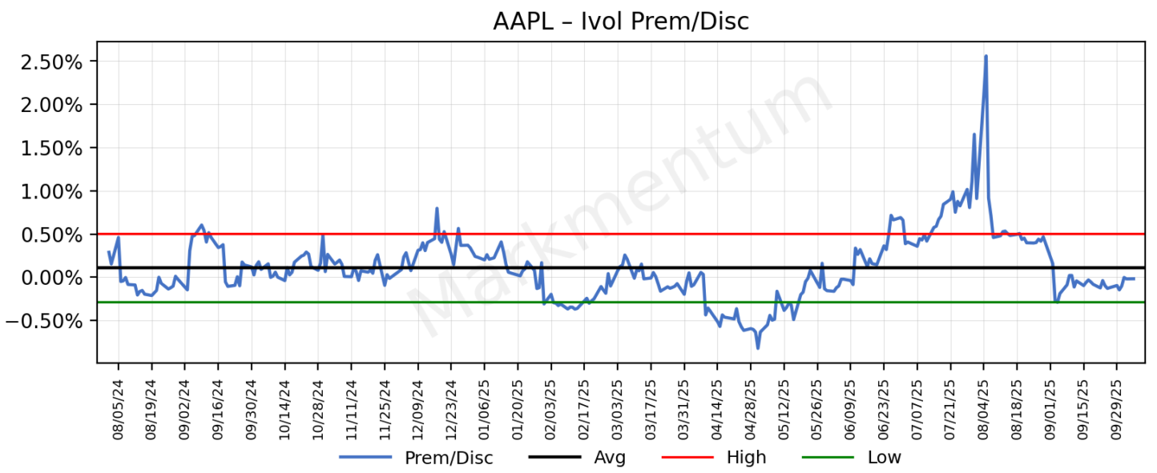
Implied volatility from option pricing compared to 30-day realized volatility. Implied Volatility Premium/Discount is the implied divided by the realized.
Implied volatility is forward looking while realized is historical. When implied is higher than the realized (i.e., IVOL Premium), investors are fearful of lower prices in the short-term future. When realized is higher, (i.e., IVOL Discount) then investors may be complacent.
This is another tool in your tool kit. No single data point is ever perfect but generally you want to sell into Implied Volatility Discount and buy into Implied Volatility Premium.
Generally, during bull market cycles volatility is episodic and non-trending. During bear markets, volatility is non-episodic and trending. Warren Buffett is famously quoted as saying “be fearful when others are greedy, and greedy when others are fearful.”
How to use:
- Above the red line (IVOL Premium) → fear is elevated; often a better time to buy into weakness.
- Below the green line (IVOL Discount) → complacency is high; often a better time to sell into strength.

Implied Volatility vs Realized Volatility Spreads
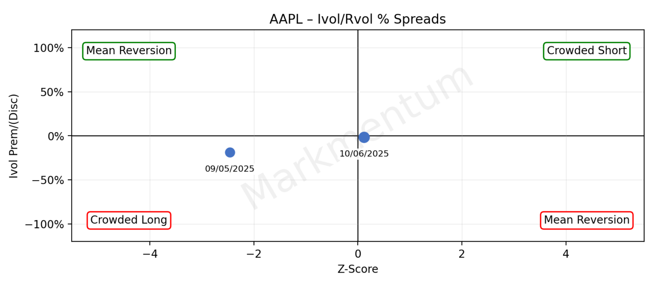
This is a quadrant graph with Implied Volatility Premium/Discount on the vertical axis and Z Score of 30-day realized volatility on the horizontal axis.
• Wide Implied Volatility Premium with elevated Z-Score is indicative of crowding on the short side which implies the price of the security could be due for a bounce.
• Wide Implied Volatility Discount with depressed Z-Score is indicative of crowding on the long side which implies the price of the security could be due for a correction.
• Wide Implied Volatility Premium with depressed Z-Score is indicative of volatility mean reverting. While not especially actionable in the moment, it tends to have forward looking implications. This could be a sign of the price of the security “climbing a wall of worry.”
• Wide Implied Volatility Discount with elevated Z-Score is also indicative of volatility mean reverting. While not especially actionable in the moment, it tends to have forward-looking implications. This could be a sign of a bottoming process in the price of the security.
How to use:
- Crowded Short (top right) → setup for bounce.
- Crowded Long (bottom left) → setup for correction.
- Mean Reversion (other quadrants) → less immediate, but forward-looking signal.

Markmentum Score
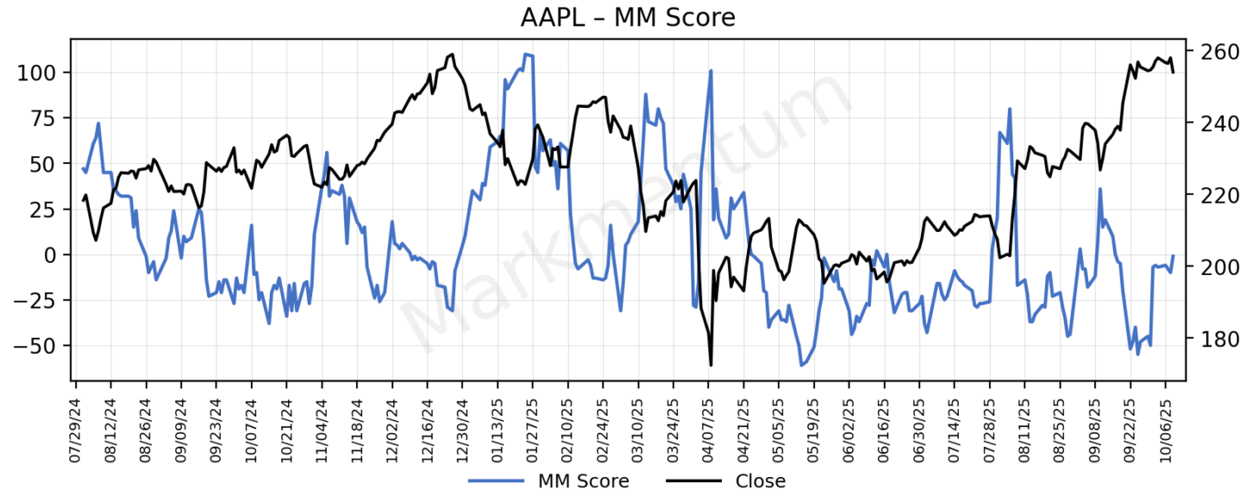
What it is
The Markmentum Score is a rules-based, volatility-adjusted risk/reward framework. It distills multiple signals into a single, intuitive scale from –100 to +100.
- Big positive → setups skew toward buy the dip.
- Big negative → setups skew toward fade the rip.
- Near zero → no edge today.
How it works
The score weighs what institutions watch every day:
- Location vs Probable Ranges & Anchors — anti-stretch context.
- Trend alignment — ST/MT vs LT, improving vs deteriorating.
- Volatility regime — realized-vol z-rank with IV premium/discount context.
- Crowding — Ivol – Rvol spreads (crowded short/long vs mean-revert)
- Quality/Persistence — Sharpe rank
All of these factors are blended with guardrails and scaling that keep quiet markets near zero, and only push when multiple conditions align.
Why it matters
The pinnacle of Markmentum Research is a disciplined, rules-based contrarian score built to avoid chasing stretch, spot crowding, and size conviction sensibly. It’s the same style of framework institutions rely on—delivered with transparency and consistency.
How to use
- Scores near +100 → risk/reward tilts positive, but conviction comes from convergence of multiple signals.
- Scores near −100 → risk/reward tilts negative, often when price is stretched and crowded.
- Scores near zero → no trade edge; better to conserve capital.
Important Guardrail Rules to Note:
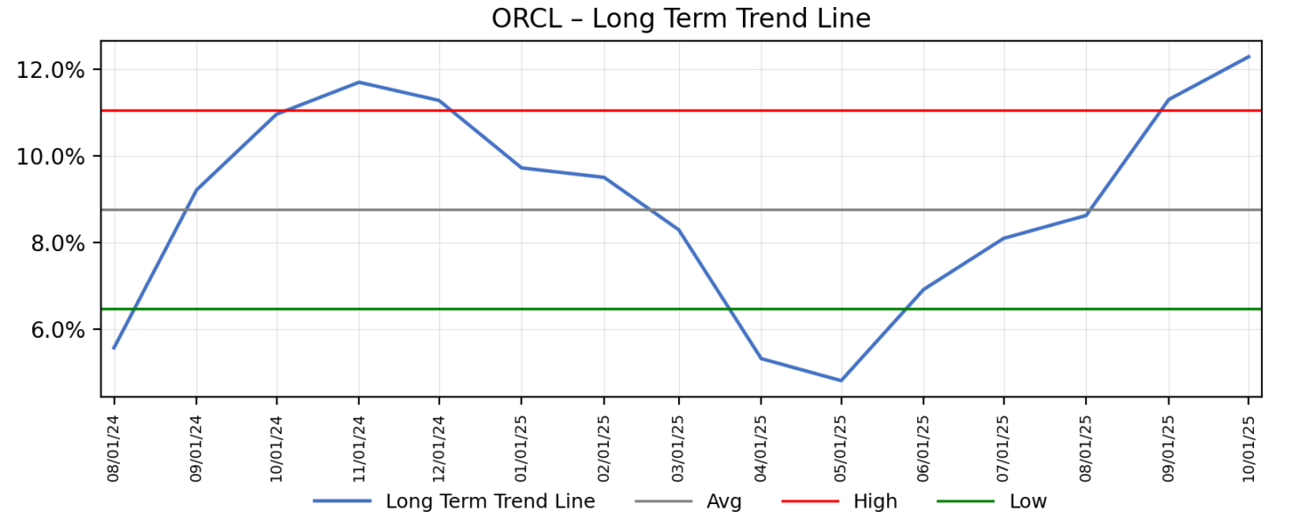
Mean-reversion guardrail (15% haircut): When the Long-Term Trend rises at or above its High line (mean + 1σ), we reduce the score by 15% to account for mean-reversion risk.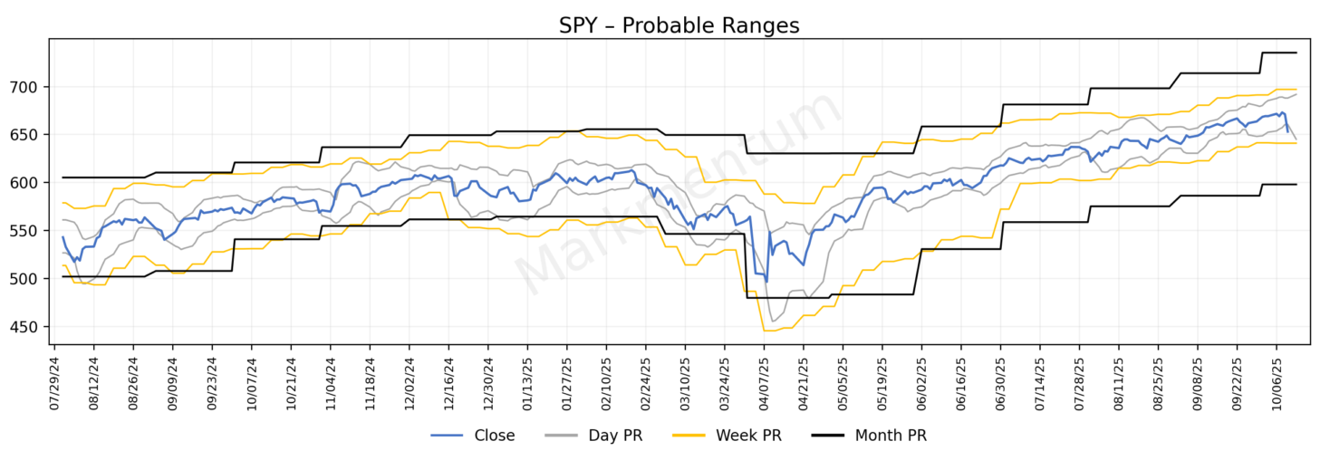
Uncertainty guardrail (score = 0): When both the Day and Week probable-range low falls at or below the Month probable-range low, timeframes are in conflict. We set the score to zero until the conflict clears.
Market Reads:
The AI-generated Market Reads on the Daily, Weekly, Monthly, and Quarterly Overview pages frame growth and inflation expectations based on market behavior. Understanding which regime the market is signaling helps investors align positioning with the prevailing macro environment.
Regimes
- Growth Accelerating, Inflation Slowing – Favorable regime for risk-on assets.
- Growth Accelerating, Inflation Accelerating – Favorable for growth stocks, momentum, and higher-beta assets.
- Growth Slowing, Inflation Accelerating – Favorable for gold and commodities.
- Growth Slowing, Inflation Slowing – Unfavorable for risk assets; favorable for safer exposures such as gold, bonds, and USD.

